Complying with the Unique Device Identification regulations for medical devices

Understand the regulatory requirements for supplying medical devices in Australia

Version 0.7, December 2024

**Copyright**

© Commonwealth of Australia 2024  
This work is copyright. You may reproduce the whole or part of this work in unaltered form for your own personal use or, if you are part of an organisation, for internal use within your organisation, but only if you or your organisation do not use the reproduction for any commercial purpose and retain this copyright notice and all disclaimer notices as part of that reproduction. Apart from rights to use as permitted by the *Copyright Act 1968* or allowed by this copyright notice, all other rights are reserved and you are not allowed to reproduce the whole or any part of this work in any way (electronic or otherwise) without first being given specific written permission from the Commonwealth to do so. Requests and inquiries concerning reproduction and rights are to be sent to the TGA Copyright Officer, Therapeutic Goods Administration, PO Box 100, Woden ACT 2606 or emailed to <[**tga.copyright@tga.gov.au**](mailto:tga.copyright@tga.gov.au)>.

Contents

Purpose 6

Legislation 6

Introduction 6

The Australian UDI system 7

Purpose of UDI 7

Australian UDI system 7

Global alignment 7

Unique Device Identifier (UDI) 8

UDI-Device Identifier (UDI-DI) 8

UDI-Production Identifier (UDI-PI) 8

UDI example 9

UDI Carrier 9

UDI in the Essential Principles 9

Noncompliance 10

Application for consent to import, supply or export a medical device that does not comply with the Essential Principles 10

General principles 10

Manufacturer role and obligations 10

Sponsor role and obligations 11

Sponsor of medical devices supplied by multiple sponsors 11

Third party role and obligations 12

Devices to meet UDI requirements 12

Medical devices that need to comply with UDI requirements 12

In vitro diagnostic devices that need to comply with UDI requirements 12

Devices exempt from UDI requirements 13

Export only devices 13

Australian UDI requirements 14

Getting a UDI 14

TGA recognised UDI Issuing Agencies 14

Packaging levels 14

Base package 15

Secondary and tertiary packages 16

Packaging example 16

Packaging level data in the Australian UDI Database 17

Unit of Use Device Identifier (UoU DI)  17

UDI labelling 18

UDI Carrier form 18

Automatic Identification Data Capture (AIDC) 18

Human Readable Interpretation (HRI) 19

Date formats 19

Examples of UDI Carrier conventions 20

Placement 21

Direct marking 21

Example of direct marking 22

Direct marking exemptions 23

Remanufacture, own brand or private labellers 23

Australian UDI labelling considerations 24

United States (US) and European Union (EU) UDI compliant labels 24

UDI requirements for specific medical device types 25

In vitro diagnostic (IVD) medical devices 25

Single use devices 26

Reusable devices 26

Personalised medical devices 27

Patient-matched medical devices 27

Custom-made medical devices 28

Medical device production systems 28

Dental sponsors and manufacturers 29

Dental practitioners 29

Implantable dental devices 29

Implantable devices 30

Surgical Loan Kits (SLK) 30

System or Procedure Packs (SOPP) 31

Systems that are medical devices 31

Systems that are configurable 32

Components or accessories supplied separately from the system 35

In vitro diagnostic systems 36

Medical device software 36

UDI assignment 36

UDI placement 37

Devices principally sold in retail 37

Medical device accessories 37

Spare or replacement parts 38

The Australian UDI Database (AusUDID) 38

UDI record history 38

AusUDID and the Australian Register of Therapeutic Goods (ARTG) 38

AusUDID data elements and rules 39

Data entry rules 39

UDI Trigger data elements 39

Multiple sponsors of the same device 40

Data element rules for multiple sponsors of the same device 40

Correcting or updating a UDI record with multiple sponsors of the same device 40

Submitting UDI data 40

Accessing the AusUDID 40

Submission by third party 40

Correcting and updating UDI data 41

Updating UDI data 41

Correcting data 41

Corrections or updates by third party data providers **Error! Bookmark not defined.**

UDI and TGA processes 42

Recalls, adverse events and device incident reports 42

Patient Implant Cards 42

Patient Information Leaflets 43

Electronic Instructions for Use 43

Certifications and audits 43

Record keeping requirements 43

Fees and charges 44

Resources 44

UDI information and support 44

Appendices 45

Examples of a UDI Carrier on device labels 45

GS1 UDI Carrier example 45

HIBCC UDI Carrier example 46

ICCBBA UDI Carrier example 46

UDI HRI formats 47

GS1 standards 47

HIBCC standards 47

ICCBBA standards 49

## Purpose

**We have drafted this guidance to help you as a sponsor or manufacturer understand your regulatory obligations under therapeutic goods legislation. Specifically, this information covers:**

* medical devices and in vitro diagnostic (IVD) medical devices included in Unique Device Identification (UDI) regulations
* labelling requirements
* data submission requirements
* specific device requirements.

This document outlines the processes to get and apply a UDI, and submit and maintain UDI data in the Australian UDI Database (AusUDID).

**For this document:**

* *we* refers to the Therapeutic Goods Administration (TGA)
* *you* refers to sponsor or manufacturer of medical devices or IVD devices
* *medical devices* refers to both medical devices and IVDs.

For a full list of definitions, see [UDI glossary](https://www.tga.gov.au/how-we-regulate/manufacturing/manufacture-medical-device/unique-device-identification-udi-hub/udi-resources-and-technical-documents/unique-device-identification-udi-glossary).

### Legislation

Please refer to the official version of legislation on the [Federal Register of Legislation](https://www.legislation.gov.au/) website when reading any information on our website relating to Australian legislation. Legislative instruments are amended from time to time and may occasionally be replaced or new instruments made.

## Introduction

The Australian Government is strengthening patient safety by introducing the Australian UDI system for medical devices.

UDI supports the identification of medical devices and other [medical device reforms](https://www.tga.gov.au/how-we-regulate/supply-therapeutic-good/supply-medical-device/medical-devices-reforms). It is designed to improve the effectiveness of the regulatory framework, including management of post-market safety-related activities, such as recalls.

The inability to effectively and efficiently track and trace devices that have been supplied to or implanted into patients has constrained timely clinical and regulatory action in a number of medical device safety crises. This includes hip implants, urogynaecological mesh and breast implant-associated lymphoma.

The TGA has established the Australian UDI system. By introducing UDI, Australia joins a globally harmonised approach that enables more accurate identification of medical devices.

|  |  |
| --- | --- |
| Information | **The introduction of UDI in Australia does not supersede or negate any existing requirements or obligations of a sponsor or manufacturer of medical devices supplied in Australia.**  **UDI requirements are in addition to existing requirements.** |

## The Australian UDI system

### Purpose of UDI

The main purpose of the Australian UDI system is to improve patient safety. When adopted in the supply chain, clinical and other health systems, UDI can enable easier and faster identification of medical devices.

UDI can provide faster identification of devices implanted into patients in the event of an adverse event, safety alert or recall. UDI can support identification and removal of those devices from storage and distribution to prevent further use.

It also allows patients, consumers, and health professionals to access product information in the AusUDID about the devices that they use. The AusUDID provides an easy to access and consistent location for up-to-date product information.

UDI could improve device performance assessment by regulatory bodies, clinical quality registries and device manufacturers through accurate product identification that better supports comparative studies.

#### Australian UDI system

The Australian UDI system is designed to improve the effectiveness of our pre-market assessments. UDI is also designed to improve the management of post-market safety-related activities. It has the potential to enable specific devices with issues to be identified quickly and appropriate action to be taken.

The establishment of the Australian UDI system is one of the medical device reforms as outlined in [An Action Plan for Medical Devices](https://www.tga.gov.au/resources/publication/publications/medical-devices-reforms-action-plan-medical-devices). It is a key pillar for the surveillance and monitoring of medical devices.

Development of UDI in Australia has involved:

* amending the [*Therapeutic Goods Act 1989*](https://www.legislation.gov.au/C2004A03952/latest/text) (the Act) and the [*Therapeutic Goods (Medical Devices) Regulations 2002*](https://www.legislation.gov.au/F2002B00237/latest/text)(the Regulations)
* developing the AusUDID
* consulting with sponsors and manufacturers of medical devices
* consulting with the healthcare community about UDI and use in the healthcare supply chain
* working with the [Australian Commission for Safety and Quality in Healthcare (ACSQHC)](https://www.safetyandquality.gov.au/) and state-based healthcare pilot sites to inform use and adoption of UDI in healthcare organisations.

#### Global alignment

We have worked to harmonise the Australian UDI requirements with global UDI requirements where possible. These include:

* aligning with the [International Medical Device Regulators Forum (IMDRF) UDI Guidance IMDRF/UDI WG/N7FINAL:2013](https://www.imdrf.org/sites/default/files/docs/imdrf/final/technical/imdrf-tech-131209-udi-guidance-140901.pdf) and [IMDRF UDI System Application Guide](https://www.imdrf.org/sites/default/files/docs/imdrf/final/technical/imdrf-tech-190321-udi-sag.pdf)
* recognising internationally accepted Issuing Agencies:
  + GS1
  + Health Industry Business Communications Council (HIBCC)
  + International Council for Commonality in Blood Banking Automation (ICCBBA)
* accepting European Union (EU) Medical Device Regulations (MDR) and EU In Vitro Diagnostic Regulations (IVDR) UDI compliant labels
* accepting United States (US) UDI compliant labels
* minimising Australian only requirements, while maintaining Australian regulatory requirements.

### Unique Device Identifier (UDI)

A UDI is made up of 2 parts:

* UDI Device Identifier (UDI-DI)
* UDI Production Identifier (UDI-PI).

To be compliant with Australian UDI requirements, you must get your UDI from one of our recognised Issuing Agencies. Your UDI must conform with the rules of the Issuing Agency you choose.

The UDI is used on labelling and applicable packaging to convey important product information.

#### UDI-Device Identifier (UDI-DI)

**The UDI-DI is the unique numeric or alphanumeric code that identifies the model of medical device.**   
The UDI-DI is the ‘access key’ to information stored in the AusUDID. It is used when reporting device related regulatory events such as adverse events and recalls. It is used to distinguish a model of medical device from other models, and find up-to-date information about the device.

Examples of the UDI-DI include:

* GS1 Global Trade Item Number (GTIN)
* Health Industry Bar Code – Universal Product Number (HIBC-UPN)
* International Council for Commonality in Blood Banking Automation Information Standard for Blood and Transplant 128 - Processor Product Identification code (ICCBBA ISBT 128-PPIC).

#### UDI-Production Identifier (UDI-PI)

**The UDI-PI identifies the production specific information such as the batch, lot or manufacturing date of the device’s production run.**   
The UDI-PI is present on the device itself or the device package, and all applicable levels of packaging, but not stored in the AusUDID. The UDI-PI supports device related reporting of regulatory events such as adverse events and recalls.

#### UDI example

An example of a UDI. The UDI-DI and UDI-PI are combined to form the full UDI. 
The UDI is the fixed, static portion of the UDI. The UDI-PI is the dynamic portion of the UDI that identifies production information such as batch number or manufacturing date. 

Figure 1: Example of a UDI

### UDI Carrier

The UDI Carrier is the means to convey the UDI. The UDI Carrier must include the UDI in both Automatic Identification Data Capture (AIDC) and Human Readable Interpretation (HRI) forms.

Your device must bear a UDI Carrier on the label, or on the device itself, and on all applicable higher levels of device packaging unless otherwise excepted. Higher levels of device packaging do not include shipping containers.

|  |  |
| --- | --- |
| Information | The UDI Carrier is not to replace any other existing labelling requirements that apply under either:   * the [*Therapeutic Goods Act* *1989*](https://www.legislation.gov.au/C2004A03952/latest/text) * the [*Therapeutic Goods (Medical Devices) Regulations 2002*](https://www.legislation.gov.au/F2002B00237/latest/text). |

See Appendix A: examples of a UDI Carrier on device labels.

### UDI in the Essential Principles

We have amended the Essential Principles in Schedule 1 of the *Therapeutic Goods (Medical Devices) Regulations 2002* to set out the requirements for UDI. This includes:

* requirements for obtaining the UDI from a TGA recognised Issuing Agency
* requirements for the labelling of a medical device and all applicable higher levels of packaging (if any) with the UDI unless otherwise excepted
* requirements for the Direct Marking of a medical device with a UDI (where applicable)
* requirements for the inclusion of UDI(s), and related information, in the AusUDID.

We have also amended related Essential Principle 13A. This requires that you must include a UDI for an implantable medical device on Patient Implant Cards, unless otherwise exempt.

#### Non-compliance

As the UDI requirements form part of the Essential Principles, we may take regulatory action if you are non-compliant with the UDI requirements, including:

suspension or cancellation of your devices from the Australian Register of Therapeutic Goods (ARTG)

applying civil penalties as outlined in Part 4-11, Division 1 of the Act

issuing infringement notices.

You can learn more about compliance actions [here](https://www.tga.gov.au/how-we-regulate/compliance-and-enforcement-hub/compliance-actions-and-outcomes).

#### Application for consent to import, supply or export a medical device that does not comply with the Essential Principles

If you cannot meet the UDI requirements by the mandatory compliance date for your medical device you can apply for [consent to supply](https://www.tga.gov.au/resources/resource/forms/essential-principles-consent-non-compliance). You must lodge, and we must approve, applications before any applicable mandatory compliance dates.

We will only grant approval for consent to supply for a specified period of time.

Where we grant consent to supply for a device, your ongoing regulatory responsibilities remain. Among them are undertaking recall actions and reporting of adverse events. You can learn more about your post-market responsibilities for medical devices [here](https://www.tga.gov.au/resources/guidance/understanding-your-post-market-responsibilities-medical-devices).

### General principles

With the UDI requirements included in the Essential Principles, you must ensure the devices you supply in Australia meet UDI requirements, unless exempt.

Your UDI and related data must be available in the AusUDID at the time your medical device is supplied in Australia. Your UDI record must remain indefinitely.

#### Manufacturer role and obligations

As a medical device manufacturer, your role and obligations include:

* choosing a TGA recognised Issuing Agency
* assigning UDIs to your devices using the relevant coding standard set by one of our recognised Issuing Agencies
* applying the UDI Carrier in HRI and AIDC form on:
  + the label
  + on the device itself, if applicable
  + all higher levels of packaging, if applicable
* ensuring that the UDI Carrier is in addition to, and does not replace any existing labelling requirements for Australia
* ensuring the UDI is globally unique to the model of device and all packaging levels
  + containing, unless otherwise excepted, both the [UDI-DI](#_UDI-Device_Identifier_(UDI-DI)) and the [UDI-PI](#_UDI-Production_Identifier_(UDI-PI)) in the UDI
* direct marking the UDI Carrier on reusable medical devices, where applicable
* assigning a new UDI-DI when there is a change to your device that could lead to misidentification or ambiguity in its traceability (UDI Trigger data elements)
* providing the UDI and related data to the AusUDID, either yourself or through your Australian sponsor
* designing, producing, packaging and labelling of the medical device
* demonstrating compliance with the relevant Essential Principles for your medical device, including those that relate to labelling
* ensuring that you meet all requirements in the Essential Principles (including that the chosen UDI Carrier is appropriate for the expected use).

Your obligations for UDI requirements are in addition to, and do not override, any existing obligations you have as a manufacturer.

#### Sponsor role and obligations

As a sponsor, your role and obligations include:

* ensuring that your manufacturer has complied with their obligations relating to UDI requirements
* ensuring that, where applicable, your manufacturer has assigned a UDI to devices you supply, before making the device available
* ensuring that the chosen UDI Carrier format is appropriate for the expected use
* submitting the UDI and related data for the devices you supply to the AusUDID according to UDI requirements
* ensuring you meet all Essential Principles.

Your obligations for UDI requirements are in addition to, and do not override, any existing obligations you have as a sponsor.

|  |  |
| --- | --- |
| Information | If you are both the sponsor and manufacturer, you must meet the UDI requirements for both roles. |

#### Sponsor of medical devices supplied by multiple sponsors

Your obligations as a sponsor do not change even if the device(s) you supply are also supplied by other sponsors. You are still responsible for submitting and maintaining the UDI and related information to the AusUDID according to the UDI requirements. Learn more about multiple sponsors here.

#### Third party role and obligations

As a manufacturer, you may choose to allow a third party to apply the UDI Carrier on your behalf. In this circumstance, you as a manufacturer remain responsible for the conformity of the UDI Carrier.

As a sponsor, you may choose to allow a third party to submit the UDI and related data to the AusUDID on your behalf. In this circumstance, you as a sponsor remain responsible for the data submitted.

As a third party, you are responsible for ensuring that you meet UDI requirements.

Our [TGA Business Services (TBS)](https://www.tga.gov.au/how-we-regulate/tga-business-services-tbs) will manage the applicable system accesses and privileges for each party.

### Devices to meet UDI requirements

Medical devices and IVDs that you supply in Australia and [must be included on the ARTG](https://www.tga.gov.au/resources/resource/guidance/how-determine-if-your-product-should-be-included-artg) must comply with UDI requirements, unless otherwise exempt.

To comply with UDI requirements, you must meet all the general principles. If applicable, you must also:

* meet any extra requirements, such as Unit of Use DI or Direct Marking
* meet any device specific requirements
* meet all further requirements as stipulated in the Regulations.

#### Medical devices that need to comply with UDI requirements

The following table describes which medical device classifications must meet UDI requirements.

|  |  |  |
| --- | --- | --- |
| Device classification | Risk | UDI required? |
| Class I | Low | NO |
| Class Im (measuring) | Low-medium | NO |
| Class Is (supplied sterile) | Low-medium | YES |
| Class IIa | Low-medium | YES |
| Class IIb | Medium-high | YES |
| Class III | High | YES |

As a manufacturer, you may choose to assign and apply a UDI to your Class I and Class Im medical devices. If you do apply a UDI to these devices, you must ensure the UDI and relevant data complies with all our UDI requirements.

As a sponsor, you may choose to submit and maintain the relevant data to the AusUDID for Class I and Class Im medical devices. If you do submit the data for these devices to the AusUDID, you must ensure the data complies with all our UDI requirements.

#### In vitro diagnostic devices that need to comply with UDI requirements

The following table describes which IVD classifications must meet UDI requirements.

|  |  |  |
| --- | --- | --- |
| IVD classification | Risk | UDI required? |
| Class 1 | No public health risk or low personal risk | PARTIAL* |
| Class 2 | Low public health risk or moderate personal risk | YES |
| Class 3 | Moderate public health risk or high personal risk | YES |
| Class 4 | High public health risk | YES |

*IVDs using the following [Global Medical Device Nomenclature](https://www.gmdnagency.org/) Collective Term must comply with UDI requirements:

* instrument/analyser IVDs (GMDN Code CT943)
* software IVDs (GMDN Code CT944).

As a manufacturer, you may choose to assign and apply a UDI to other exempt IVDs. If you do apply a UDI to these IVDs, you must ensure the UDI and relevant data complies with all our UDI requirements.

As a sponsor, you may choose to submit and maintain the relevant data to the AusUDID for other exempt IVDs. If you do submit the data for these IVDs to the AusUDID, you must ensure the data complies with all our UDI requirements.

### Devices exempt from UDI requirements

You are not required to meet UDI requirements for medical devices and IVDs exempt from inclusion in the ARTG under Schedule 4 of the Regulations. For example, medical devices that are:

* custom-made
* patient matched with a volume of 5 or less supplied each financial year
* exempt under Special Access Scheme (SAS) or Authorised Prescriber (AP) Scheme
* class 1, 2, 3 and 4 in-house IVDs.

|  |  |
| --- | --- |
| Information | While these devices are exempt from complying with UDI requirements, as a sponsor you can choose to:   * supply exempt devices with UDIs and UDI-compliant labels * submit the relevant data to the AusUDID. |

#### Export only devices

You do not need to meet UDI requirements for medical devices and IVDs that are:

* intended for export only from Australia
* strictly not for supply in Australia.

You may however need to meet UDI requirements of the country you supply the device to.

## Australian UDI requirements

### Getting a UDI

As a manufacturer, you must apply and get a UDI from one of our recognised Issuing Agencies. This is to ensure that the UDI is globally unique and complies with global standards.

|  |  |
| --- | --- |
| Information | You will **not** be compliant with Essential Principles if your UDI is allocated by any Issuing Agency or other party that is **not** one of our 3 recognised Issuing Agencies. |

#### TGA recognised UDI Issuing Agencies

We recognise the following UDI Issuing Agencies:

|  |  |
| --- | --- |
| Issuing Agency | Contact |
| GS1 | [customer.service@gs1au.org](mailto:customer.service@gs1au.org) |
| Health Industry Business Communications Council (HIBCC) | [info@hibcc.org](mailto:info@hibcc.org) |
| The International Council for Commonality in Blood Banking Automation (ICCBBA) | [Support@isbt128.org](mailto:Support@isbt128.org) |

### Packaging levels

You must apply the UDI on the device itself or its packaging, as well as all applicable higher levels of packaging. Higher levels of packaging do not include shipping containers or logistics containers.

As a manufacturer, you must assign a different UDI at each level of packaging containing a quantity of medical devices. For example a single device, carton or case. This does not include shipping containers such as pallets or other logistics containers. The purpose of this is to support identification of medical devices at all points in supply and inventory management systems.

The UDI-DI must be globally unique at all levels of packaging and follow the rules of the Issuing Agency chosen by the manufacturer.

**Example of packaging levels**

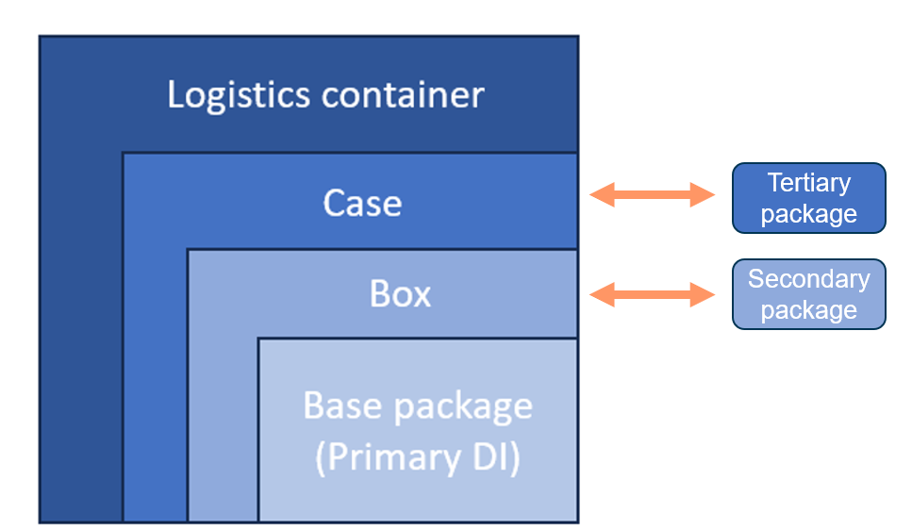

Figure 2: Example of packaging levels

#### Base package

The base package is the lowest level of the device packaging. In some cases, the base package is the only device packaging.

The UDI-DI that you apply to the base package is used as the Primary DI. The UDI-DI for the base package, or Primary DI, is the ‘key’ to the UDI record in the AusUDID.

If there is more than one unpackaged and unlabelled device in the base package, your device must also have a Unit of Use DI. You must supply the Unit of Use DI to the AusUDID. For more information, see Unit of Use DI.

If there is more than one unpackaged device in the base package, but the devices are directly marked, your devices do not need a Unit of Use DI. However, you must also provide the Direct Marking DI to the AusUDID.

|  |  |
| --- | --- |
| Information | A Direct Marking DI could be the same as the Primary DI or different to distinguish it from the packaged device. As a manufacturer, it is your responsibility to decide if you wish to make this distinction. As the sponsor, it is your responsibility to ensure the data in the AusUDID reflects this decision.  Scenarios where the Direct Marking DI may be different to the Primary DI for a device include where a device is:   * Packaged in both single and multiple packs * Provided both in sterile and non-sterile packaging * Provided in different sizes which are sold together. |

#### Secondary and tertiary packages

The levels of packaging above the base package are known as ‘Secondary’ and ‘Tertiary’ packages.

Secondary packages contain a set number of base packages of a device.

Tertiary packages contain a set number of secondary packages of a device.

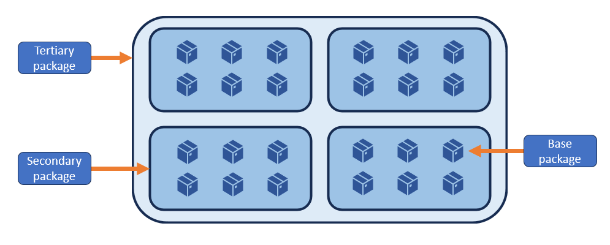

Figure 3: Example of the relationship between base package, secondary package and tertiary package

As a manufacturer, you must allocate a different UDI-DI to each level of a device package.

#### Packaging example

An example of a packaging configuration that shows a base package that contains a single syringe with a UDI-DI for the base package of ABC1237. 
The secondary package is a carton of 6 boxes (or base packages) of the syringe. The UDI-DI for the secondary package level is ABC1238. 
The tertiary package is a case of 4 cartons that each contain 6 boxes (or base packages) of the syringe. The UDI-DI for the tertiary level of packaging is ABC1239. 
This demonstrates the requirement for each level of packaging to have a different UDI-DI. 


Figure 4: Example of a packaging configuration with a base package, a secondary package and a tertiary package

Figure 4 shows a base package that contains a single syringe with a UDI-DI for the base package of ABC1237.

The secondary package is a carton of 6 boxes (or base packages) of the syringe. The UDI-DI for the secondary package level is ABC1238.

The tertiary package is a case of 4 cartons that each contain 6 boxes (or base packages) of the syringe. The UDI-DI for the tertiary level of packaging is ABC1239.

This demonstrates each level of packaging having a different UDI-DI.

|  |  |
| --- | --- |
| Information | If the base package contains more than one unpackaged and unlabelled medical device, you must assign a Unit of Use DI. |

#### Packaging level data in the Australian UDI Database

You must link all Package DI levels to your UDI record for the Base Package UDI-DI (also referred to as the Primary UDI-DI).

|  |  |
| --- | --- |
| Information | In the circumstance where there are multiple sponsors for a medical device that bears the same UDI, packaging configurations may differ. In all scenarios, the manufacturer must still assign the UDI for the device and all applicable levels of device packaging. |

### Unit of Use Device Identifier (UoU DI)

The Unit of Use Device Identifier (UoU DI) is an identifier assigned to an individual medical device when:

* you supply more than one device in a base package, making the device count greater than one, and
* you have not labelled or directly marked the individual devices.

The purpose of the UoU DI is to allow identification a device used on a patient when a UDI does not appear on the label of the device.

The UoU DI is also known as the ‘Virtual UDI’ as you do not need to physically place a UoU DI on each device. You must however submit the UoU DI and device count data to the AusUDID. The UoU DI does not replace the Primary DI, and the base package remains the lowest trade level.

The UoU DI must follow the UDI rules of the Issuing Agency chosen by the manufacturer for the Primary DI.

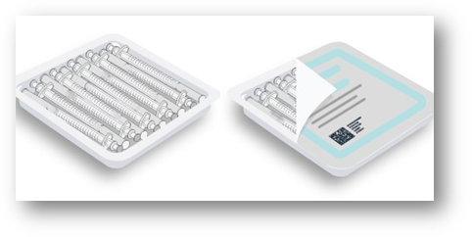

Figure 5: Example of device package that requires UoU DI

|  |  |
| --- | --- |
|  | **Sam the manufacturer and sponsor**  Sam manufacturers a tray of 25 syringes (figure 5). Sam applies the full UDI to the tray per the standard UDI labelling requirements.  To allow the individual device to be associated with and tracked to a specific patient, Sam allocates a separate UoU UDI-DI to each syringe. The UoU DI is the same for each individual device within the tray. Sam does not need to label the syringes in the tray with the UoU DI, as it is a virtual identifier only.  Sam supplies the UoU DI and Device Count information in the AusUDID with the Primary DI and other mandatory device data.  The Device Count reflects the number of devices in the base package (the tray). For Sam’s tray, the Device Count is 25. |

|  |  |
| --- | --- |
| Information | You do **not** need to allocate a UoU UDI-DI or Device Count to procedure packs or kits. Individual devices that already require a Unit of Use DI will inherit this requirement.  Because of their use, Unit of Use is not suitable for IVD devices. |

## UDI labelling

### UDI Carrier form

The UDI Carrier on the label or on the device itself and all higher packaging levels must be presented in 2 forms:

* Human Readable Interpretation (HRI)
* Automatic Identification Data Capture (AIDC).

This is to ensure the device can be both read by humans and read by machines.

Both the AIDC and HRI must follow the rules of your chosen Issuing Agency.

|  |  |
| --- | --- |
| Information | The HRI portion of the UDI Carrier must include data delimiters. This allows the identifiers to be distinguished in the string of characters that follow the data delimiter.  Data delimiters vary between Issuing Agencies. Your chosen Issuing Agency can help you with data delimiters and formats. |

#### Automatic Identification Data Capture (AIDC)

We have not restricted the AIDC form to a specific symbology, noting that some symbologies may be more appropriate for specific settings or use.

AIDC technology that you may use includes:

* linear barcodes (1D)
* data matrix barcodes (2D)
* smart cards, biometrics
* Radio Frequency Identification (RFID).

As a manufacturer, if you use RFID technology, you must comply with open and commercially acceptable, international standards such as ISO 17366:2013. You must also provide a linear, 2D barcode or another type of barcode on the label to maintain usability for systems with varying technological capabilities.

#### Human Readable Interpretation (HRI)

The HRI is to be:

* a legible interpretation of the data characters encoded in the UDI Carrier
* usually presented next to or below the AIDC form of the UDI Carrier.

In the HRI portion of the UDI Carrier, the UDI should precede any non-UDI elements. You should order the HRI portion of the UDI to specify the UDI-DI first, followed by the UDI-PI (if any). If there are any non-UDI elements in the UDI carrier, the non-UDI elements should follow the UDI-PI. The HRI data and the applicable data delimiters allow for UDI data to be accurately captured manually when the AIDC porting cannot be captured.

#### Date formats

To minimise confusion and uncertainty, we recommend that you use the following format for plain text dates on your device label:

* the year, using 4 digits
* the month, using 2 digits
* the day, using 2 digits.

We recommend that you separate each component with a hyphen.

|  |  |
| --- | --- |
| Information | We offer this recommendation based on ISO 8601-1:2019. |

**Date format examples**

YYYY-MM-DD

2024-12-25

Another way you may express the date to reduce ambiguity:

12 NOV 2025

**Date format in UDI-PI**

When you include the date as part of the UDI-PI, you may present the date as YYMMDD. For example, 241225.

#### Examples of UDI Carrier conventions

If you use linear bar codes, the UDI-DI and UDI-PI can be concatenated or non-concatenated in 2 or more bar codes. All parts and elements of the linear bar code must be distinguishable and identifiable.

**Concatenated barcode**

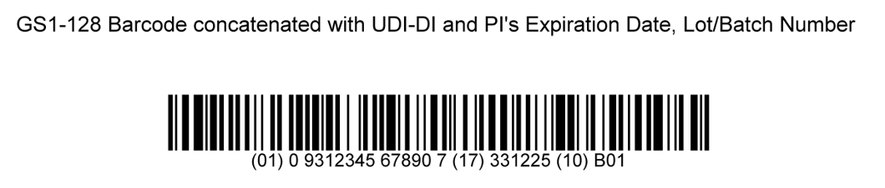

Figure 6: A single linear barcode that includes UDI-DI and UDI-PI in the AIDC and HRI

**Non-concatenated barcode**

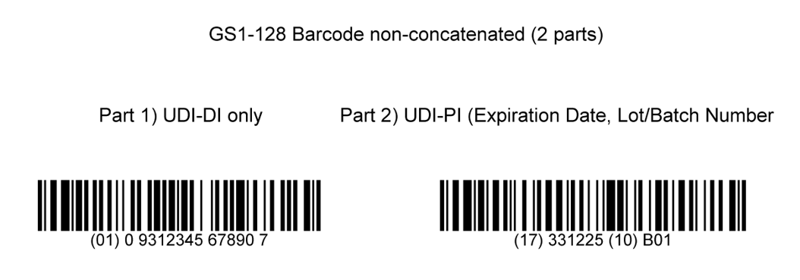

Figure 7: 2 separate barcodes, one represents UDI-DI and the second represents the UDI-PI

|  |  |
| --- | --- |
| Information | While acceptable under UDI regulations, using non-concatenated barcodes may need extra training for warehouse staff to understand the order and need to scan both barcodes. It is the manufacturer’s responsibility to decide whether concatenated or non-concatenated are more appropriate. |

**2D barcode**

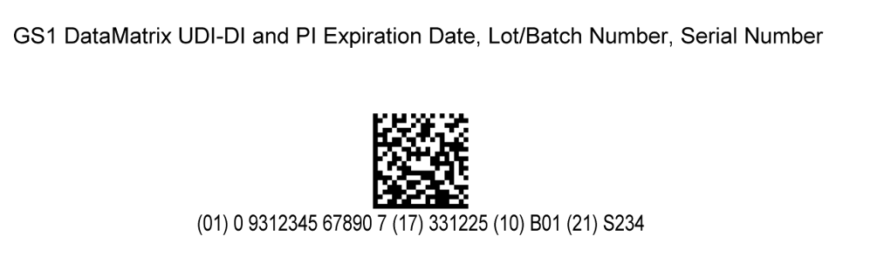

Figure 8: Combines UDI-DI and PI into a single 2D barcode

### Placement

As a manufacturer, you are responsible for determining the most appropriate placement of the UDI Carrier. You should place the UDI Carrier in a way that the AIDC can be accessed during normal operation or storage.

|  |  |
| --- | --- |
| Information | If there are significant constraints limiting the use of both AIDC and HRI on the label, the AIDC form shall be favoured. However, certain environments or use situations, such as home care, may warrant the use of HRI over AIDC.  As a manufacturer, you are responsible for determining whether the constraints are significant and limit the above use. We may check this as part of our existing audits. |

### Direct marking

Direct marking supports identification when the device is no longer accompanied by its label or package that contains the UDI.

|  |  |
| --- | --- |
| Information | We do not consider equipment that contains labelling on the device itself or has a UDI printed directly on the device as party of labelling to be direct marked. Examples include:   * MRI machines * IV pumps.   You are expected to label these devices with a UDI (unless otherwise exempt); however we do not use the term ‘direct marking’. |

As a manufacturer, you must directly mark the full UDI indelibly[1] onto the device itself if your device is:

* intended to be reusable, and
* reprocessed between use on different patients.

We do not specify how you directly mark your device. There are many options available for the direct marking of devices. Your chosen Issuing Agency can recommend suitable methods of direct marking and can give guidance on standards that will apply.

As a manufacturer, you are responsible for:

* determining the method of direct marking
* ensuring the direct marking can withstand the normal usage and cleaning procedures for the lifetime of the device.

If there are significant constraints limiting the use of both AIDC and HRI on the label, the AIDC form shall be favoured. However, certain environments or use situations, such as home care, may warrant the use of HRI over AIDC.

As a manufacturer, it is your responsibility to give your reasoning for the UDI Carrier form selected, when requested by us.

A manufacturer’s determination on whether a device is reusable will be considered as part of the application for inclusion submitted to us. You should reflect this in the instructions for use with any relevant information on appropriate processes for allowing reuse.

|  |  |
| --- | --- |
| Information | A Direct Marking DI could be the same as the Primary DI or different to distinguish it from the packaged device. As a manufacturer, it is your responsibility to decide if you wish to make this distinction. As the sponsor, it is your responsibility to ensure the data in the AusUDID reflects this decision.  Cases where the direct marking UDI-DI may be different to the Primary DI for a device include where a device is:   * Packaged in both single and multiple packs * Provided both in sterile and non-sterile packaging * Provided in different sizes which are sold together. |

#### Example of direct marking

Figure 9 demonstrates one of the possible methods for direct marking. This example illustrates how a manufacturer has directly marked the UDI Carrier both HRI and AIDC.

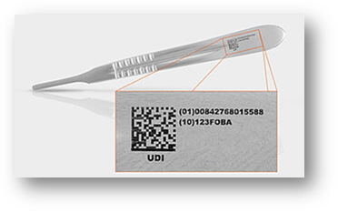

Figure 9: Example of a medical device that a manufacturer has directly marked with a UDI

#### Direct marking exemptions

Direct marking exemptions apply for:

* devices that are reprocessed between uses on the same patient[2]
* implantable devices
* devices where any type of direct marking would interfere with the safety or performance or effectiveness of the device
* devices where it is not technically feasible to directly mark the device.

When a medical device is exempt from direct marking, the UDI must be on the next level of packaging.

|  |  |
| --- | --- |
| Information | As a manufacturer, it is your responsibility to give your reasoning for not meeting the direct marking requirements, when requested by us. |

Devices that you manufacture and label before their direct marking mandatory compliance dates are exempt from direct marking requirements for the lifetime of the device.

### Remanufacture, own brand or private labellers

You are considered the manufacturer, and must meet UDI requirements for your devices, if you are a:

* reprocessor of single use medical devices
* remanufacturer
* relabeller
* own brand/private labeller.

Re-manufacture refers to one or more of the following activities carried out on single use devices to supply for reuse:

* assembling the device
* packaging the device
* processing the device
* fully refurbishing the device
* labelling the device
* assigning the device a new intended purpose by means of information supplied by, on or in the labelling, the instructions for use or advertising material.

In the process, the person responsible for undertaking these activities on a single use device has:

* changed the intended purpose of the device
* certified the device is suitable for reuse
* assumed the legal liability for the quality, safety and performance of the device.

If you do one of more of the activities that deem you to be a remanufacturer, you must meet UDI requirements, unless exempt.

|  |  |
| --- | --- |
|  | **Angus the remanufacturer**  Angus refurbished a Class Is single use medical device to supply for reuse. In the process, Angus has certified the device is suitable for reuse. He has also assumed the legal liability for the quality, safety and performance of the device. Since he did these activities, Angus has become the manufacturer of the single use device and must now meet UDI requirements. This includes Angus allocating and applying the UDI to the device.  Angus is responsible for ensuring that the previous UDI on the device, if any, is removed entirely.  As Angus is also the sponsor of the device, he must meet the obligations of a sponsor. These include submitting the UDI and related data to the AusUDID and linking the relevant ARTG to the UDI record. |

### Australian UDI labelling considerations

We recommend that you do not apply multiple barcodes on a label. This is to assist consumers and healthcare to identify the correct barcode.

If a label contains multiple barcodes, you should ensure that consumers and healthcare can easily distinguish the UDI Carrier from other barcodes.

We recommend the use of UDI ISO symbol (ISO 15223-1, UDI Graphical Symbol 5.7.10, 2021).

|  |  |
| --- | --- |
| Information | You must not remove other production identifiers on the device label even if it is also part of the UDI. This includes expiration date, manufacture date or lot number. |

### United States (US) and European Union (EU) UDI compliant labels

We accept your UDI labels that meet the UDI requirements of the EU or USFDA, if:

* the UDI has been issued by one of our recognised Issuing Agencies
* the label complies with the existing regulatory and labelling requirements for Australia.

You can supply devices in Australia that have US or EU UDI compliant labels even if they are exempt from Australian UDI requirements. We recommend that you supply this data to the AusUDID to minimise confusion for the end users.

As an Australian manufacturer that exports to the USA or Europe, you can use the US or EU UDI-compliant label in Australia.

## UDI requirements for specific medical device types

Some specific medical device types have their own UDI requirements.

### In vitro diagnostic (IVD) medical devices

As a manufacturer of IVDs, you must assign a UDI to each model of IVD unless exempt. In most scenarios, IVDs share the same UDI requirements with medical devices.

**IVD kits**

The medical device contents of your IVD kit should have a UDI Carrier on the packaging or on the device itself. If your IVD kit does not include any components which, on their own, are considered medical devices, you only need to assign and apply the UDI to the IVD kit itself.

If your IVD kit contains single use medical devices, these devices do not need a UDI where:

* the person(s) intending to use the device generally know the uses
* the single use medical devices are not intended for individual use outside the context of the IVD kit
* the single use medical devices are Class I non-measuring non-sterile or Class Im (measuring).

|  |  |
| --- | --- |
| Information | If you distribute individual single use medical devices packaged in an IVD kit as replacement parts, these devices do not need a UDI where:   * the person(s) intending to use the device generally know the uses * the single use medical devices are not intended for individual use outside the context of the IVD kit. |

If your IVD kit contains medical devices that are exempt from having a UDI on the relevant level of packaging, you do not need to apply a UDI to these devices. You may need to apply a UDI to these devices if you also supply these devices separate to the IVD kit.

|  |  |
| --- | --- |
| Information | Because of their nature, the Unit of Use DI is not appropriate for IVDs. |

**Placement of UDI on IVD kits**

You should apply the UDI Carrier to the outside of the packaging. It must be readable or scannable whether placed on the outside of the IVD kit package or inside a transparent package.

**Submission of IVD kit data to the AusUDID**

As a sponsor, you are responsible for ensuring that the following data is supplied to the AusUDID:

* UDI-DI and related data of the IVD kit
* UDI-DI of each medical device in the kit that has a UDI.

### Single use devices

A single use device is used on an individual patient during a single procedure and then discarded. It is not intended to be reprocessed and used again, even on the same patient.

You must meet UDI requirements for single use devices, where included in devices required to meet UDI requirements.

One general exception to this is where:

* you distribute individual single use devices of a single version or model together in a single device package, and
* these devices are intended to be stored in that device package until removed for use.

In this circumstance, you must apply the UDI to the device package rather than on the device.

|  |  |
| --- | --- |
| Information | This exception is not available for any implantable device. |

If the device is intended for individual commercial distribution, you must meet UDI requirements for the individual device.

The UDI Carrier for single use medical devices packaged and labelled individually does not need to be on its package. The UDI Carrier must however be on a higher level of packaging, for example a carton. When the end user (for example, healthcare provider) is not expected to have access to the higher level of device packaging, the UDI Carrier should be on the device’s packaging.

Reprocessors of single use medical devices are considered the manufacturer of the reprocessed device. Reprocessors must create their own, new UDI for the reprocessed medical device which will replace the Original Equipment Manufacturer’s (OEM) UDI (where it exists). This reprocessed device will then be subject to the UDI requirements.

Single use devices are exempt from Unit of Use UDI-DI requirements where the device:

* is not reprocessed
* is not commercially available
* the person(s) intending to use the device generally know the uses.

As a manufacturer, you must meet UDI requirements for multipacks and higher levels of single use device packaging.

### Reusable devices

If you design or intend for your device to be reprocessed for reuse, your device is a reusable device. Reusable devices are intended to:

* be used more than once on the same or different patients
* undergo high-level disinfection or sterilisation before each use.

Single use only devices are not reusable devices.

As a manufacturer, if you design or intend for your device to be a reusable device you must meet direct marking requirements.

Direct marking requirements specify that the manufacturer must ensure that the UDI of reusable devices is:

* directly marked on the device itself (unless exempt)
* readable after each reprocessing.

You are also responsible for defining the PI characteristics for the Direct Marking UDI according to your quality management system.

### Personalised medical devices

Personalised medical devices[3] (PMD) are designed and manufactured, or adapted or modified, to meet the needs of an individual.

We use 3 specific terms to describe personalised medical devices:

* **patient-matched** medical devices
* **adaptable** medical devices
* **custom-made** medical devices.

The UDI requirements for each of these types of personalised medical devices vary, with each described separately below.

|  |  |
| --- | --- |
| Information | Before 25 February 2021, most personalised medical devices met the definition of ‘custom-made’. These devices were exempt from the requirement to be approved by us and included in the ARTG before they could be imported, exported or supplied.  Following extensive consultation and liaison with other global regulators, we developed a new regulatory framework for PMD. We introduced this new framework to ensure an appropriate level of regulation is applied to PMD to manage the risk they may pose. The new framework came into effect on **25 February 2021**, and includes:   * new definitions for personalised medical devices, including patient-matched and adaptable medical devices, which reduce the scope of the custom-made medical device exemption * changes to the conditions of exemption for [custom-made medical devices](https://www.tga.gov.au/node/289270) * new requirements for the inclusion of a Medical Device Production System (MDPS) in the ARTG. |

For guidance specific to personalised medical devices including 3D printed devices, see [Personalised medical devices (including 3D-printed devices) (tga.gov.au)](https://www.tga.gov.au/sites/default/files/2023-12/personalised-medical-devices-including-3d-printed-devices.pdf).

#### Patient-matched medical devices

As a sponsor or manufacturer, you must meet UDI requirements for patient-matched medical devices if:

* you manufacture more than 5 per financial year (and so must be included in the ARTG), and
* the devices are of a classification that is included in Devices required to meet UDI requirements.

#### Custom-made medical devices

Custom-made medical devices are exempt from meeting UDI requirements.

Note that most of the devices that were previously supplied under the custom-made medical device exemption now meet the definition of patient-matched medical device. You must meet UDI requirements for patient-matched medical devices must meet UDI requirements, unless otherwise exempt.

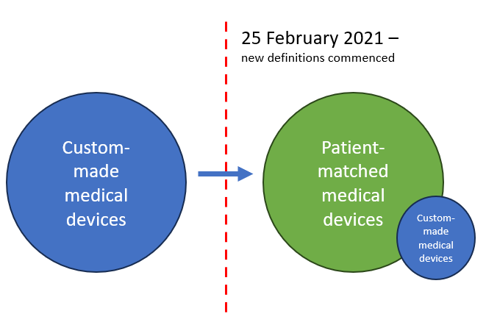

Figure 10: Illustration of relationship between custom-made medical devices and patient-matched medical devices after new definitions commenced

#### Medical device production systems

Medical Device Production System (MDPS) means a system that:

* consists of raw materials and main production equipment (whether or not the system also consists of software)
* the manufacturer intends to be used (whether or not with ancillary inputs or equipment) by a health professional, or suitably qualified person in a healthcare facility, and
* produces a particular medical device for use in relation to a patient of the health professional or healthcare facility.

As a manufacturer or sponsor of a MDPS, you must ensure that:

* the appropriate conformity assessment procedures have been applied to the MDPS relevant to its classification, demonstrating it, and all devices it produces, meet all relevant Essential Principles
* the MDPS is included in the ARTG with the same classification as the highest class of device it is intended to produce
* the MDPS meets UDI requirements where the MDPS classification is included in Medical devices required to comply with UDI rules.

For guidance specific to MDPS, see [Personalised medical devices (including 3D-printed devices) (tga.gov.au)](https://www.tga.gov.au/sites/default/files/2023-12/personalised-medical-devices-including-3d-printed-devices.pdf).

#### Dental sponsors and manufacturers

You must meet UDI requirements for any dental devices that:

* are in scope of Medical devices required to comply with UDI rules
* are included in the ARTG.

#### Dental practitioners

As a registered dental practitioner, you have responsibilities to act in accordance with The Dental Board of Australia’s standards, codes, and guidelines.

You must be aware of and comply with other laws and regulations, including regulatory responsibilities to the TGA when:

* importing dental devices (a sponsor)
* manufacturing dental devices away from chair-side (a manufacturer and a sponsor).

You must meet UDI requirements where your dental device requires ARTG inclusion, and is included in Medical devices required to comply with UDI rules.

For example, you must meet UDI requirements for:

* finished or unfinished dental devices you have imported from overseas
* materials and/or components intended to be used to make a dental device for use in your practice
* dental devices made from materials or components bought from an Australian-based supplier who has not included the materials and/or components in the ARTG
* implantable dental devices even when manufactured using materials and/or components bought from an Australian-based supplier who has included the materials and/or components in the ARTG.

As a dental practitioner, if you do any of the above activities, it is likely you are the sponsor of the device. You must meet sponsor regulatory responsibilities, including but not limited to UDI requirements.

You do not need to meet UDI requirements if you buy:

* finished devices from an Australian-based sponsor who has already met UDI requirements
* materials and components to manufacture non-implantable dental medical devices from an Australian-based sponsor who has already met UDI requirements.

#### Implantable dental devices

As a sponsor, or a dental practitioner acting as a sponsor, you must include meet UDI requirements for implantable dental devices.

Implantable dental devices are not exempt from ARTG inclusion or UDI requirements when made using materials included in the ARTG. Examples of implantable dental devices include:

* dental implants and implant abutments
* implant abutments with special attachments
* temporary anchorage devices (TADS), such as Mini screws.

Dental devices attached to implant abutments or fixed to TADS are exempt from ARTG inclusion and UDI requirements when made using ARTG included materials. Examples include:

* crowns
* bridges
* fixed or removable non-implant orthodontic appliances.

### Implantable devices

Because of the high risks with implantable devices, the UDI for an implantable device should be identifiable and able to be recorded before implantation. This can minimise the risks of misidentification of the implanted device.

The following UDI requirements apply for implantable devices:

* all base packages of implantable devices need to be identified by checking the UDI before surgery and captured at the point of implantation
* the UDI must be in both HRI and AIDC formats
* the UDI-PI should include:
  + for an active implantable device, the serial number
  + for other implantable devices, the serial number or lot number per the manufacturer's quality management system.

|  |  |
| --- | --- |
| Information | You do not need to directly mark the UDI on implantable devices. |

|  |  |
| --- | --- |
| Information | Examples of labels that you may use to support identifying implantable devices include:  a tear-away tag bearing the UDI  peel-off labels bearing the UDI affixed to autoclave box holding the implantable device. |

### Surgical Loan Kits (SLK)

Surgical loan kits (SLK) are exempt from requiring a UDI at the kit-level. The item for transporting the devices in the kit (tray, tub or case) is considered a logistics unit which does not need a Package DI. Additionally, the items in an SLK are not considered co-packaged medical devices.

Your SLK component requires a UDI if it is classified as Class Is, Class IIb, Class IIa, or Class III, unless it is:

* not commercially available on their own
* otherwise exempt from UDI requirements.

The UDI (UDI-DI and UDI-PI) for each medical device component in an SLK must be easily accessible at the point of care. This will allow the linking of the medical devices to their implantation or use on patients.

We acknowledge the global challenges to assigning UDI identification to devices in surgical loan kits, as typical UDI labelling methods are often not feasible. To reduce these challenges, we are not prescribing the method you use to provide the UDI. We aim to be consistent with the flexibility offered by other international regulators. This includes allowing provision methods such as stickers, tags, inventory sheets and data carrier strips.

### System or Procedure Packs (SOPP)

You must assign a system or procedure pack (SOPP) a UDI if it contains one or more medical device in scope of the UDI requirements.

Your SOPP does not need a UDI on the pack if it only contains:

* medical devices that are Class I – with a measuring function, or
* medical devices that are Class I non-sterile or non-measure.

However, the assembler or manufacturer of the SOPP may choose to apply a UDI to these SOPPs.

Any component of a SOPP that is a medical device that is in scope of UDI requirements must have a UDI unless the medical device is:

* not commercially available on its own
* an individual single-use disposable device where the person(s) using them generally know the uses; and are not intended for individual use outside the context of the SOPP. For example, an unpackaged sterile syringe in a sterile pack cannot be used for another procedure once removed from the pack
* exempt from UDI requirements.

Medical device components that you supply separately from the SOPP must be included in the ARTG and comply with UDI requirements, unless exempt.

### Systems that are medical devices

A System is 2 or more goods that the manufacturer intends to be connected, used together or combined to achieve a specific medical purpose. The goods may be packaged together or packaged separately.

A System is **not**:

* a single item
* a collection of miscellaneous items that the manufacturer does not intend to be used together for a specific medical purpose
* bulk packs of one or more items
* a procedure pack (though a procedure pack can include a system in it).

|  |  |
| --- | --- |
| Information | Examples of Systems that are medical devices include:  knee-joint replacement System  orthopaedic drill System  a patient-monitoring System with a monitor, power cable, and backup power supply  a blood-glucose monitoring kit with a blood-glucose meter, test strips, controls, lancets, and a lancing device. |

As a manufacturer, you must allocate a UDI to the System that is a medical device in the same way as other medical devices.

As a sponsor, you must supply the UDI and related data for the System to the AusUDID in the same way as other devices. You must also ensure the GMDN Code provided to the AusUDID covers the system.

|  |  |
| --- | --- |
| Information | UDI requirements for Systems that are medical devices do not supersede or override any existing requirements, including Instructions for Use requirements. |

#### Systems that are configurable

For Systems that can be configured, as a manufacturer you must allocate a UDI to the entire configurable System. This is known as the System UDI.

As a manufacturer, you must allocate a System UDI-DI to defined groups of configurations. You are responsible for defining the groups as the collection of possible configurations for a given product line as described in a regulatory file.

You must allocate a System UDI-PI to each individual System. A later change of a component, sub-System or accessory of the System does not change the UDI-PI of the System.

As a manufacturer, you should place the System UDI Carrier on the assembly that most likely does not get exchanged in its lifetime.

As a manufacturer you must ensure that each component, sub-System or accessory has a separate UDI if:

it is a medical device

it is included on the ARTG, and

it is in scope of devices required to meet UDI requirements.

As a manufacturer, you are responsible for:

* allocating a new UDI-DI when the activities performed modify a previously marketed device intended for resale which leads to a new medical device
* determining that the activities performed result in a new medical device.

You do not need to allocate a new UDI-DI when the activities performed do not lead to a change or modify the performance, safety, or intended use, of a previously marketed device intended for resale.

For specific devices and under specific circumstances, it might be needed to be able to uniquely identify the changed device configurations.

If a change to a device that you have distributed changes:

* the safety
* performance, or
* intended purpose.

and these changes are not in the limits of the original configuration, those changed devices should be identifiable.

To make the changed device identifiable, as a manufacturer you must provide an upgrade kit with a corresponding UDI which meets all UDI requirements. The UDI of the upgrade kit with the original System UDI will be used to identify the changed device.

An alternative would be that the manufacturer performs this change as a new installation (comparable with the resale of a modified device). The new installed device would need to be marked with a corresponding new System UDI.

**Changes that require identification of changed devices**

As a manufacturer, you must ensure changed devices are identifiable, where changes are made to devices in distribution and the change impacts:

* safety
* performance
* intended use, or
* indications for use of the device.

**Example: Upgrade to system which impacts safety or performance**

|  |  |
| --- | --- |
|  | **Claire the manufacturer**  **MRI system**  Claire manufactures an MRI System, 'Model A', that she manufactures and distributes to customers. She develops new features and functionality for that MRI system which are her original approved specifications do not cover. This could be hardware, software or a combination of both. The new features change the safety profile, the performance of the system or the intended uses. Claire determines this results in a new model, 'Model B', of the device. If Claire decides to modify the device as a new installation, she must give the modified device a new System UDI. Alternatively, she may provide an upgrade kit as a medical device with a separate UDI. This with the original System UDI is used for the identification of the changed device. |

**Example: Component change which impacts safety or performance**

|  |  |
| --- | --- |
|  | **Alice the manufacturer**  **X-ray system**  Alice manufactures an X-ray System with a 50 kV generator. She changes the 50kV generator to a 100 kV generator. Alice’s original configuration(s) do not specify for these generator options, and her change alters the performance of the System. Alice determines this is a new version or model of the System. If Alice decides to modify this device as a new installation, she must give a new System UDI to the modified device. Alternatively, Alice may provide an upgrade kit as a medical device with a separate UDI. This with the original System UDI is used for the identification of the changed device. |

**Example: New diagnostic feature, not previously approved, added to device**

|  |  |
| --- | --- |
|  | **Bella the manufacturer**  **Cardiac ultrasound system**  Bella manufacturers a cardiac ultrasound System. She introduces a new diagnostic algorithm on the cardiac ultrasound system allowing new data calculations and imaging options. The algorithm introduces new indications for use and changes the performance of the System. Bella determines that this change results in a new model or version of the system according to her documented procedures for assessing device changes. If Bella decides to modify this device as a new installation, she must give the modified device a new System UDI. Alternatively, Bella may provide an upgrade kit as a medical device with a separate UDI. This with the original System UDI is used for the identification of the changed device. |

**Examples of changes where the UDI remains unchanged**

As a manufacturer, you do not need to allocate a new UDI where a changed device does not require the device to be specifically identified from the original device.

**Example: System component changed of an installed device; no change in safety or performance**

|  |  |
| --- | --- |
|  | **Indigo the manufacturer**  **CT system**  Indigo manufactures a CT System. One of Indigo’s installed CT Systems has an X-ray tube which has reached the end of its life. Indigo replaces this tube with a newer model tube without other changes to the device or its labelling. Indigo determines that this is not a new version or model of the system, according to the documented and approved description of the configuration. For example, the safety profile, the performance of the System and the intended use are unchanged. As there is no significant change to the safety, performance or the intended purpose, the UDI remains unchanged. |

**Example: A customer-selectable option changed for an installed device**

|  |  |
| --- | --- |
|  | **Olivia the manufacturer**  **CT system**  Olivia manufactures a CT System that has an approved medical device ARTG inclusion, which includes several diagnostic algorithms. When a customer orders the device, they can choose which algorithms they would like activated based on their business model. A customer with an installed System purchases another diagnostic algorithm which was approved for the System because of their changing business needs. The extra algorithm may be installed or activated and does not lead to a new model or version of the System. In this circumstance, the System UDI remains unchanged. |

**Example: Addition of an accessory for an installed device**

|  |  |
| --- | --- |
|  | **Matilda the manufacturer**  **System used with accessories**  Matilda manufactures a System that customers can use with accessories. Customers adding or using accessories with the System is covered by what is originally specified for the defined groups of configurations. A customer adding or using an accessory with the System does not lead to a new model or version of the System. In this circumstance, the System UDI remains unchanged. |

#### Components or accessories supplied separately from the system

As a manufacturer, you must allocate a UDI to each component of the System that is a medical device (for example, accessories and consumables), if the component is:

* supplied separately (commercially available on its own)
* included in Medical devices required to comply with UDI rules.

|  |  |
| --- | --- |
| Information | For example, you must include an Automated External Defibrillator (AED) that you supply with electrodes and batteries in the AusUDID as a System. You must include replacement batteries and electrodes in the AusUDID separately if they have separate ARTG IDs. |

We recommend you link the UDI record(s) of the components or accessories to the ARTG ID for the System you supply them in, as well as their own ARTG ID.

|  |  |
| --- | --- |
|  | **Maddie the sponsor**  **System used with accessories that are sold separately**  Maddie is a sponsor who supplies a System that customers can use with accessories. Maddie also supplies the accessories separately (commercially available on their own). Maddie has an ARTG inclusion for the accessories different ARTG to the system. However, the System and accessories are covered by what is originally specified for the defined groups of configurations. In this circumstance, Maddie links the UDI record for the accessory to both the ARTG for the System and the ARTG for the accessory. |

#### In vitro diagnostic systems

Many IVD Systems use test reagents and accessories that are higher class medical devices than the instrument with which they are used. You must include the reagents and accessories in the AusUDID separately from the instrument.

### Medical device software

You are required to meet UDI requirements for medical devices and IVDs that are software or incorporate software unless they are exempt.

Software specific UDI labelling and data provision requirements depend on factors such as:

* the type of software
* whether it is a physical product
* whether you supply the software packaged or unpackaged.

#### UDI assignment

As the manufacturer, you must assign the UDI at the system level of the Software as a Medical Device (SaMD). The version number of your SaMD is the manufacturing control mechanism and you must include it in the UDI-PI.

If your SaMD changes in the following way, you must assign a new UDI-DI to your device:

* major SaMD revision where a complex or significant change affects:
  + - * the original performance and effectiveness
      * the safety or intended use of the SaMD.

These changes include but are not limited to:

* new or modified algorithms
* database structures
* operating platform
* architecture
* new user interfaces
* new channels for interoperability.

If your SaMD changes in the following way, you must assign a new UDI-PI (but not a new UDI-DI):

* minor SaMD revisions, including but not limited to:
* bug fixes
* usability enhancements (not for safety purpose)
* security patches
* operating efficiency.

You should identify minor revisions by manufacturer specific identification methods such as:

* version
* revision number
* serial number.

#### UDI placement

If you supply your SaMD in a physical medium, each package level must have the UDI in HRI and AIDC readable formats. For example, a CD or DVD.

The UDI that is applied to the base package of the physical medium containing the SaMD and its packaging must be identical to the UDI assigned to the system level SaMD.

You should also provide the UDI on a readily accessible screen by the user in an easily readable plain-text formatting. For example, an ‘About’ file or box included in the startup screen.

If your SaMD lacks a user interface, it must be capable of transmitting the UDI through an Application Programming Interface (API).

You only need to provide the HRI portion of the UDI in electronic displays of the SaMD. You do not need to include the AIDC marking in the electronic displays.

You must include the Data Delimiter in the HRI form. This helps the end user to identify the UDI and determine which standard you have used to create the UDI.

If you label your SaMD with a physical UDI, but later perform an upgrade in which your device requires a new UDI-DI, you may provide this new UDI-DI through the electronic display method. We recommend you inform the end user to remove the physical UDI carrier to minimise confusion.

### Devices principally sold in retail

If you principally sell your device in retail, you only need to meet certain UDI Carrier labelling requirements.

As a manufacturer, you must allocate and apply a UDI-DI to your devices in both AIDC and HRI forms. However you only need to apply the UDI-PI in HRI form. You may choose to apply the UDI-PI in AIDC form; however this is on a voluntary basis.

You must meet all UDI requirements for all other applicable levels of packaging.

|  |  |
| --- | --- |
| Information | As a manufacturer, you do not need to meet direct marking requirements for retail devices. |

As a sponsor, you must meet all regulatory requirements for retail devices.

### Medical device accessories

An accessory is a product that the manufacturer specifically intends to be used with a device. The accessory allows or helps the device to be used, in a way that the manufacturer of the device intended.

As a manufacturer, you must meet UDI requirements for accessories if your accessory (including components and sub-systems):

* is considered a medical device in its own right
* is commercially available
* has its own ARTG inclusion, and
* is in scope of devices required to meet UDI requirements.

You do not need to meet UDI requirements if your accessory:

* is part of a convenience, medical procedure, IVD kit or system that is a medical device that has its own UDI
* is exempt from inclusion in the ARTG, or
* is otherwise exempt from UDI requirements.

### Spare or replacement parts

If you exchange a component of a device that is a device itself and has a UDI, you must meet UDI requirements for the component.

## The Australian UDI Database (AusUDID)

We have established the AusUDID as the repository for UDIs and related data in Australia.

The AusUDID stores the UDI-DI and related data for medical devices and in vitro diagnostic (IVD) devices supplied in Australia.

We have designed the AusUDID to store UDIs and related data about a model of medical device. This can help to improve tracking and traceability of medical devices supplied in Australia. When providing data to the AusUDID, you should consider information that will help the end user to distinguish the device from other models. This will help them to use current product information.

As a sponsor, you or your approved third party, can submit and maintain device data in the AusUDID. You must keep UDI data up to date while your device(s) remains in supply in Australia. Once your device is no longer in supply, the UDI data must remain indefinitely in the AusUDID.

Patients, consumers, clinical quality registries and health professionals will be able to view and download this medical device information, at no cost.

|  |  |
| --- | --- |
| Information | **Note**: The AusUDID stores UDI-DI and associated medical device data. The AusUDID does not store the UDI-PI. |

### UDI record history

All records in the AusUDID remain indefinitely.

The AusUDID includes a history of all changes to each UDI record. We store this data in the AusUDID indefinitely, and it is available at no cost to all users.

### AusUDID and the Australian Register of Therapeutic Goods (ARTG)

You must use the AusUDID to link a UDI record to your relevant medical device inclusion(s) in the ARTG.

UDI requirements and the AusUDID are in addition to and do not supersede or negate any existing requirements.

The ARTG remains the single record of the authorisation to supply a medical device or an IVD. The data in the AusUDID supports this approval by providing information on the individual models of devices approved under the ARTG inclusion.

### AusUDID data elements and rules

The Australian UDI Data Dictionary includes a list of the fields in the database, including:

* data element names
* descriptions
* permitted values
* other useful metadata.

You can find the Australian UDI Data Dictionary on the TGA Hub at [Draft Australian UDI Data Dictionary | Therapeutic Goods Administration (TGA)](https://www.tga.gov.au/how-we-regulate/manufacturing/manufacture-medical-device/unique-device-identification-udi-hub/udi-resources-and-technical-documents/draft-australian-udi-data-dictionary).

#### Data entry rules

Successful entry and updates of a UDI record are subject to the data passing the data validation requirements set out in the AusUDID Data Dictionary.

These rules include whether the field is mandatory, conditionally mandatory or optional, which may vary depending on the type of device.

|  |  |
| --- | --- |
| Information | We will publish any changes to the data elements and rules on the UDI Hub. |

### UDI Trigger data elements

Changes to certain data elements mean you must create a new UDI record. These data elements are called UDI Triggers. The overarching determinant in a UDI Trigger scenario is whether the device must be identified as different from previous uses of the device.

For example, brand name is a UDI Trigger data element. If you change the value for brand name, you must create a new UDI record with a new UDI-DI. This is because this device must be identified as different from previous uses.

As a manufacturer, you are responsible for determining whether changes to the device are UDI Triggers. Note that the AusUDID will enforce the addition of new UDI-DIs when you change the UDI Trigger data elements.

When the value for a UDI Trigger is changed and a new UDI-DI is needed:

* as a manufacturer, you are responsible for changing the affected device labels to incorporate the new UDI-DI
* as a sponsor, you are responsible for ensuring the data is submitted to the AusUDID before you supply the newly labelled device in Australia.

Note that the UDI record for the new device is separate to the previous UDI record for the previous device. You must keep the previous UDI record in the AusUDID.

The Australian UDI Data Dictionary sets out which data elements are UDI Triggers.

### Multiple sponsors of the same device

Because of the nature of therapeutic good regulation in Australia, it is possible that multiple sponsors supply the same medical device with the same UDI. We have designed the AusUDID to cater for these scenarios.

As a sponsor, you are responsible for submitting your UDI(s) and related data. This remains your responsibility, even if another sponsor supplies the same medical device with the same UDI as you.

If another sponsor has already submitted the UDI(s) and related data, you only need to add your sponsor specific data to the existing UDI record. You will be compliant with UDI requirements for submitting data, as long as you have added your sponsor specific data to the existing record.

If the data is incorrect, you must make any change as a correction.

#### Data element rules for multiple sponsors of the same device

Some data elements in the AusUDID have different rules when there are multiple sponsors for the same device. This is to ensure consistency and accuracy in the device data.

These data rules and behaviours will vary depending on whether the data element is either:

device data, or

sponsor specific data elements.

Device Data are AusUDID data fields that remain common and consistent for all sponsors of the device.

UDI Trigger data elements are also categorised as Device Data, which have extra requirements, that is, changes to this data will trigger a new UDI-DI.

Sponsor Data is AusUDID data that is specific to each sponsor of the device, for example Sponsor Name.

#### Correcting or updating a UDI record with multiple sponsors of the same device

If you make any changes to a UDI record that has other sponsor data linked, you must do this as a Correction. You must also give a reason for the change. This is to ensure consistency and accuracy in the data.

### Submitting UDI data

#### Accessing the AusUDID

Your access and abilities in the AusUDID differ subject to your organisation type and TBS role.

We have published resources on access and abilities in the AusUDID on the UDI Hub.

#### Submission by third party

As a sponsor, you may approve a third party to submit UDI data to the AusUDID on your behalf.

You must either:

* give them access through your TBS account
* add them as an agent[4], or
* allow them to submit machine to machine HL7 SPL messages on your behalf.

Resources for using third parties are on the [UDI Hub](https://www.tga.gov.au/how-we-regulate/manufacturing/manufacture-medical-device/unique-device-identification-udi-hub).

### Correcting and updating UDI data

We recognise there are many scenarios in which device data will change over time. These include:

* correcting data errors
* applying clinically relevant changes to the device
* changing Issuing Agency requirements
* where you supply a single device to multiple countries with different UDI requirements.

To accommodate this, we allow both corrections and updates to data in the AusUDID.

A summary of how the AusUDID supports updates to UDI data is below.

We have published resources for correcting or updating UDI data on the [UDI Hub](https://www.tga.gov.au/how-we-regulate/manufacturing/manufacture-medical-device/unique-device-identification-udi-hub).

#### Updating UDI data

As a sponsor, it is your responsibility to keep UDI data up to date in the AusUDID. You are to update data within 30 days if the changes do not trigger a new UDI-DI.

If you have supplied incorrect data to the AusUDID, you can correct your data error in the AusUDID. The AusUDID keeps an audit trail of the changes made, who made them and when.

If your update includes changes to a UDI Trigger data element, you have 2 options:

* create a new record for the amended device
* make a correction to an unintended error in the AusUDID.

If you need to create a new record for the amended device, you must do so as soon as you supply the device in Australia.

#### Correcting data

If you have supplied incorrect data to the AusUDID, you can correct your data error.

The method for correcting data errors varies based on whether or not the UDI record is in the ‘Grace Period’.

The Grace Period is a set time frame that begins once you have published your initial version of the UDI record. During this time frame, you can make any needed changes to any data element.

**Correcting UDI data in the Grace Period**

You can correct any errors to any data field during the Grace Period by submitting the correct data.

**Correcting UDI data outside the Grace Period**

You can correct any errors outside the Grace Period by specifying that you are undertaking a Correction. You must give your reasoning for why the change is needed. We may review Corrections to data errors.

We have published instructions on how to action a Correction to a data error on the UDI Hub.

## UDI and TGA processes

### Recalls, adverse events and device incident reports

Where a UDI is available, you must include it in recall notices, adverse event reports and device incident reports.

Where a UDI is not available, reports continue as per existing requirements and should include any applicable information.

### Patient Implant Cards

Manufacturers must provide Patient Implant Cards (PICs) and Patient Information Leaflets (PILs) for their medical devices[5].

You are required to include the following information on a PIC:

* name of the device
* model of the device
* batch code, lot number or serial number of the device
* manufacturer’s name, address, and website.

If available, you must also supply the UDI on the PIC for all implantable devices, including:

* the full UDI (UDI-DI and UDI-PI) in AIDC form
* the UDI-DI in HRI form.

This UDI information is in addition to the information already supplied on the PIC.

You should display the UDI-PI either as a single field or split into the above data elements, per the current PIC requirements.

An example of a PIC with a UDI:

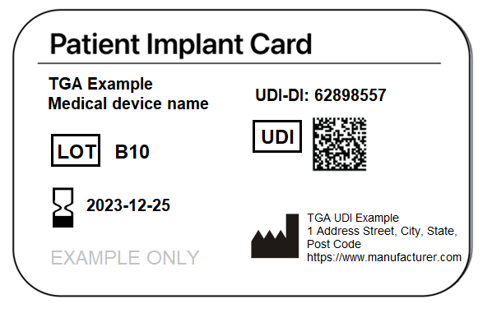

Figure 11: Example of a Patient Implant Card with a UDI

If you are unable to meet the UDI requirements for Patient Implant Cards, you will need Consent to Supply.

### Patient Information Leaflets

There are no requirements for you to include UDIs on Patient Information Leaflets (PILs).

As a sponsor, you can choose to submit PILs to the AusUDID for your devices as a URL or a PDF attachment.

As a sponsor, you are responsible for ensuring the PIL is up-to-date if submitted to AusUDID.

### Electronic Instructions for Use

You do not need to supply the UDI on Electronic Instructions for Use (eIFU), although as a manufacturer, you may choose to do so.

### Certifications and audits

You do not need to re-register or re-certify your medical devices when you amend your medical device labelling to meet the UDI requirements. This includes amending other supporting documents.

### Record keeping requirements

As a sponsor, one of your existing ongoing responsibilities is to maintain distribution records for medical devices supplied in or exported from Australia, including:

* dates
* batch/lot numbers
* product expiry dates
* volume information such as:
  + records of receipt and shipment from manufacturing sites, including records of shipping and storage conditions where required
  + records of storage and warehousing conditions where required
  + records of distribution to customers, retail outlets, hospitals, suppliers and distributors (including export countries).

We expect you to keep records for 10 years for:

* Class 4 IVDs
* Class III medical devices
* Class IIb medical devices.

For other classifications, we expect you to keep records for 5 years after you distribute the last product.

We expect that you include the UDI in your records, and keep your records for the applicable time frame based on the device’s classification.

**UDI specific record keeping requirements**

As a sponsor, you are responsible for maintaining records showing all UDIs used to identify devices that must bear a UDI on their label.

Your records should indicate whether a device was directly marked, and whether the Direct Mark DI is the same or different to the Primary DI. You should update your records when you make changes to the Production Identifiers (PIs), to reflect all PIs currently associated with each DI.

Your records should also refer to:

* the location of the DI for the particular model of device
* the associated types of PIs in the UDIs for that particular version or model of the device (such as lot number, batch number, manufacturing date).

### Fees and charges

No fees are applicable for submitting or updating your UDI data. We have included ongoing management and maintenance of the AusUDID in annual charges.

## Resources

We have published a range of resources to support you in implementing UDI and using the AusUDID. These are available on the [UDI Hub.](https://www.tga.gov.au/how-we-regulate/manufacturing/manufacture-medical-device/unique-device-identification-udi-hub/udi-resources-and-technical-documents/unique-device-identification-udi-glossary)

### UDI Support Team

We have a dedicated UDI Support Team that provides a range of services including:

* supporting you in understanding your obligations and meeting UDI requirements
* supporting you in using the AusUDID
* supporting healthcare organisations and professionals to understand the application and use of UDI in healthcare systems.

The UDI Support Team does not replace the broader medical device information or enquiry lines and support channels[6] already offered by us.

|  |  |
| --- | --- |
|  | **Contact us at** [UDI@health.gov.au](mailto:UDI@health.gov.au). |

## Appendices

### Appendix A: Examples of a UDI Carrier on device labels

Below are examples of labels from each of the 3 Issuing Agencies. We have framed the 2 parts of the UDI in each diagram:

* the UDI Carrier is framed in green
* the UDI-Device Identifier (UDI-DI) in both AIDC and HRI formats is framed in red
* the UDI-Production Identifier (UDI-PI) is framed in blue.

#### GS1 UDI Carrier example

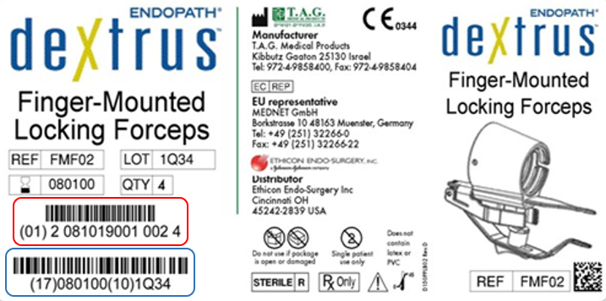

Figure 12: Example of a GS1 label with UDI Carrier

#### HIBCC UDI Carrier example

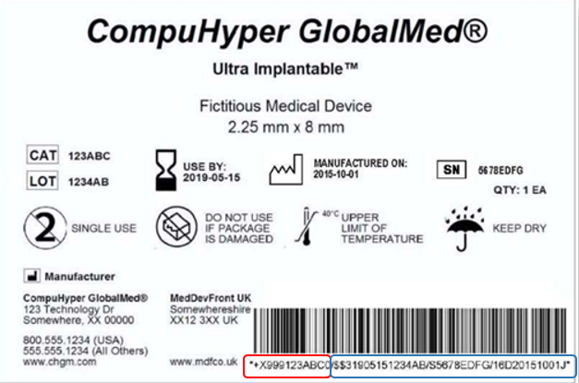

Figure 13: Example of a HIBCC label with UDI Carrier

#### ICCBBA UDI Carrier example

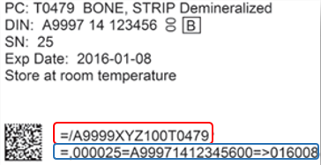

Figure 14: Example of an ICCBBA label with UDI Carrier

### Appendix B: UDI HRI formats

#### GS1 standards

|  |  |  |  |  |  |
| --- | --- | --- | --- | --- | --- |
| Issuing Agency | Data Delimiter/Application Identifier | Identifier | Data type | Human Readable Field Size | Database Field Size |
| GS1 | (01) | Device Identifier | Numeric | 16 | 14 |
| GS1 | (11) | Manufacturing/ Production Date | numeric [YYMMDD] | 8 | 6 |
| GS1 | (17) | Expiration Date | numeric [YYMMDD] | 8 | 6 |
| GS1 | (10) | Batch/Lot Number | alphanumeric | 22 (max) | 20 (max) |
| GS1 | (21) | Serial Number | alphanumeric | 22 (max) | 20 (max) |
| *GS1* |  | ***Maximum Base UDI*** | ***alphanumeric*** | ***76*** | ***66*** |
| **ex: (01)09506000117843(11)141231(17)201231(10)1234AB(21)5678CD** | | | | | |

#### HIBCC standards

|  |  |  |  |  |  |
| --- | --- | --- | --- | --- | --- |
| Issuing Agency | Data Delimiter/Application Identifier | Identifier | Data type | Human Readable Field Size | Database Field size |
| HIBCC | + | Device Identifier | Alphanumeric | 7 to 24 | 6 to 23 |
| HIBCC | $ | Lot Number Only | Alphanumeric | 19 | 18 |
| HIBCC | $$7 | Lot Number Only (alternative option) | Alphanumeric | 21 | 18 |
| HIBCC | $$ | Expiration Date followed by Lot Number | Exp. Date: numeric [MMYY] | 6 | 4 |
| Lot Number: alphanumeric | 18 | 18 |
| HIBCC | $$2 | Expiration Date followed by Lot Number | Exp. Date: numeric [MMDDYY] | 9 | 6 |
| Lot Number: alphanumeric | 18 | 18 |
| HIBCC | $$3 | Expiration Date followed by Lot Number | Exp. Date: numeric [YYMMDD] | 9 | 6 |
| Lot Number: alphanumeric | 18 | 18 |
| HIBCC | $$4 | Expiration Date followed by Lot Number | Exp. Date: numeric [YYMMDDHH] | 11 | 8 |
| Lot Number: alphanumeric | 18 | 18 |
| HIBCC | $$5 | Expiration Date followed by Lot Number | Exp. Date: numeric [YYJJJ] – Julian Date format | 8 | 5 |
| Lot Number: alphanumeric | 18 | 18 |
| HIBCC | $$6 | Expiration Date followed by Lot Number | Exp. Date: numeric [YYJJJHH] – Julian Date format with Hour option | 10 | 7 |
| Lot Number: alphanumeric | 18 | 18 |
| HIBCC | $+ | Serial Number only | Alphanumeric | 20 | 18 |
| HIBCC | $$+7 | Serial Number only (alternative option) | Alphanumeric | 22 | 18 |
| HIBCC | $$+ | Expiration Date followed by Serial Number | Exp. Date: numeric [MMYY] | 7 | 4 |
| Serial Number: alphanumeric | 18 | 18 |
| HIBCC | $$+2 | Expiration Date followed by Serial Number | Exp. Date: numeric [MMDDYY] | 10 | 6 |
| Serial Number: alphanumeric | 18 | 18 |
| HIBCC | $$+3 | Expiration Date followed by Serial Number | Exp. Date: numeric [YYMMDD] | 10 | 6 |
| Serial Number: alphanumeric | 18 | 18 |
| HIBCC | $$+4 | Expiration Date followed by Serial Number | Exp. Date: numeric [YYMMDDHH] | 12 | 8 |
| Serial Number: alphanumeric | 18 | 18 |
| HIBCC | $$+5 | Expiration Date followed by Serial Number | Exp. Date: numeric [YYJJJ] | 9 | 5 |
| Serial Number: alphanumeric | 18 | 18 |
| HIBCC | $$+6 | Expiration Date followed by Serial Number | Exp. Date: numeric [YYJJJHH] | 11 | 7 |
| Serial Number: alphanumeric | 18 | 18 |
| HIBCC | /S | Supplemental Serial Number, where lot number also required and included in main secondary data string | Alphanumeric | 20 | 18 |
| HIBCC | /16D | Manufacturing Date (supplemental to secondary barcode) | numeric [YYYYMMDD] | 12 | 8 |
| HIBCC | /14D | Expiration Date (supplemental to secondary barcode as optional format) | numeric [YYYYMMDD] | 12 | 8 |
| *HIBCC* |  | ***Maximum Base UDI*** | ***Alphanumeric*** | ***70 to 87*** | ***58 to 75*** |
| **Ex of Human Readable Barcode: +H123PARTNO1234567890120/$$420020216LOT123456789012345/SXYZ4567890123 45678/16D20130202C** | | | | | |

#### ICCBBA standards

|  |  |  |  |  |  |
| --- | --- | --- | --- | --- | --- |
| Issuing Agency | Data Delimiter/Application Identifier | Identifier | Data type | Human Readable Barcode  Field Size | Database Field Size |
| ICCBBA | =/ | Device Identifier | Alphanumeric | 18 | 16 |
| ICCBBA | =, | Serial Number | Alphanumeric | 8 | 6 |
| ICCBBA | = | Donation Identification Number | Alphanumeric | 16 | 15 |
| ICCBBA | => | Expiration Date | numeric [YYYJJJ] | 8 | 6 |
| ICCBBA | =} | Manufacturing Date | numeric [YYYJJJ] | 8 | 6 |
| ICCBBA | &,1 | MPHO Lot Number | Alphanumeric | 21 | 18 |
| ICCBBA |  | ***Maximum Base UDI for HCT/Ps*** | ***Alphanumeric*** | **79** | **67** |
| **Ex of Human Readable Barcode:=/A9999XYZ100T0944=,000025=A99971312345600=>014032=}013032&,1000000000000XYZ123** | | | | | |

Version history

|  |  |  |  |
| --- | --- | --- | --- |
| Version | Description of change | Author | Effective date |
| V0.1 | Original draft | Devices Reforms Taskforce | May 2024 |
| V0.2 | Updated document based on:   * Edits by XO * Edits by RO | Devices Reforms Taskforce | June 2024 |
| V0.3 | Updated document based on:   * Edits by DET * Edits by TP | Devices Reforms Taskforce | July 2024 |
| V.04 | Updated document based on:   * Edits by TD | Devices Reforms Taskforce | August 2024 |
| V0.5 | Updated document based on:   * External feedback | Devices Reforms Taskforce | November 2024 |
| V.06 | Updated document based on:   * Internal analysis | Devices Reforms Taskforce | November 2024 |
| V0.6 | Updated document based on:   * Edits by CW | Devices Reforms Taskforce | December 2024 |

1. In a way that cannot be removed.
2. Please note that if the device is subsequently reprocessed for use on another patient, the direct marking exemption will not apply.
3. [Personalised medical devices (including 3D-printed devices) | Therapeutic Goods Administration (TGA)](https://www.tga.gov.au/resources/resource/guidance/personalised-medical-devices-including-3d-printed-devices)
4. [Add or remove an Agent from your organisation | Therapeutic Goods Administration (TGA)](https://www.tga.gov.au/resources/resource/forms/add-or-remove-agent-your-organisation)
5. [Patient implant cards and information leaflets | Therapeutic Goods Administration (TGA)](https://www.tga.gov.au/products/medical-devices/breast-implant-hub/patient-implant-cards-and-information-leaflets)
6. [Contact us | Therapeutic Goods Administration (TGA)](https://www.tga.gov.au/about-tga/contact-us#business-area-contacts)